Project Design Phase-II Technology Stack (Architecture & Stack)

Date | 03 October 2022
Team ID | PNT2022TMID53527
Project Name | Smart Fashion Recommender Application
Maximum Marks | 4 Marks

Technical Architecture:
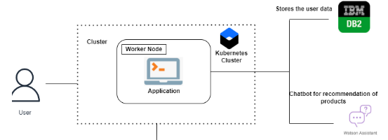

Table-1 : Components & Technologies:

S.No | Component | Description | Technology
1. | User Interface | How user interacts with application e.g. Web UI, Mobile App, Chatbot etc. | HTML, CSS, JavaScript
2. | Application Logic-1 | Logic for a process in the application | Python
3. | Application Logic-2 | Logic for a process in the application | IBM Watson STT service
4. | Application Logic-3 | Logic for a process in the application | IBM Watson Assistant
5. | Database | Data Type, Configurations etc. | MySQL
6. | Cloud Database | Database Service on Cloud | IBM DB2
7. | File Storage | File storage requirements | IBM Block Storage
8. | Infrastructure (Server / Cloud) | Application Deployment on Cloud  Cloud Server Configuration : Db2 /python | Kubernetes,

Table-2: Application Characteristics:

S.NoCharacteristicsDescriptionTechnology1.Open-Source FrameworksFlaskPython2.encryption hashing and saltingEncryption hashing and saltingEncryptions3.Scalable ArchitectureGetting resources to different parts of the system that need itMicroservices Architecture4.AvailabilityThe Application available 24/7IBM Cloud5.Performance1000 request per dayIBM Watson

